**ACKNOWLEDGEMENT**

We express our sincere thanks and heart felt gratitude to Prof. **Seetharaman**, Vice-

Chancellor, SASTRA for permitting us to do the project work in a successful manner.

We express our profound gratitude to **Dr. S. Jayalalitha**, Associative Dean, School of

Electrical &amp; Electronics Engineering, SASTRA for his inspiring presence throughout the

duration of our project.

We are blessed to have had the guidance and full support of **Prof. BAGYALAKSHMI.G**, Assistant Professor II, SEEE, SASTRA throughout our project work. We run out of

words when we try to express our deep-rooted thanks for their invaluable guidance,

excellent support, expert advice and enthusiastic participation. Without them our project

would not have seen the light of the day.

**ABSTRACT**

**KEYWORDS** ---- virtual instrumentation, systolic parameters, electrocardiograph, Photoplethysmogram, arrhythmia, LabVIEW

To aid patients and physicians in healthcare, the system "VI BASED HEMODYNAMIC MONITOR" was developed. Atypical heartbeat is referred to as an arrhythmia. It may be so brief that it has little effect on heart rate as a whole, yet it can make heart rate too sluggish or too high. It's possible that the heart can't pump enough when arrhythmias are severe or persist a long time. The patient could become exhausted or lose consciousness as a result of this. To identify arrhythmias, an electrocardiogram is frequently employed. In order to identify and categories the patient's anomalies and abnormalities, this system was designed to collect data from the patient's ECG, PPG, and BODY TEMPERATURE. In this research, a Virtual Instrumentation-based prototype for assessing systolic parameters derived from the calculation of hemodynamic index and ejection fraction is presented. As a result, one can evaluate the patient's cardiovascular activity and body temperature based on the results. Additionally, this prototype will phone and send alert messages to the patient's guardian and monitoring doctor. The proposed prototype is non-intrusive, low cost, compact, and graphical user-friendly. It also incorporates integrated hardware and software. This prototype generates electrocardiographic and photoplethysmography real-time cardiovascular signals that are sampled utilizing specialized sensor signals and an Arduino Uno device. A LabVIEW application from National Instruments receives data. An GSM is an essential component of this prototype's application allows the user to receive calls and alert messages at the registered phone number. To provide a preliminary assessment of the cardiovascular pathology, data are provided simultaneously with the signal from the sensor's calculation. As a result, it will make a good prototype to use in general medical or family practice settings where using specialized equipment is not required.

**LIST OF TABLES:**

|  |  |  |
| --- | --- | --- |
| **TABLE NUMBER** | **NAME** | **P.NO** |
| 1 | INTRODUCTION | 9 |
| 2 | ELECTROCARIO GRAPH | 11 |
| 3 | PHOTOPLETHYSMOGRAM | 13 |
| 4 | DESIGN AND CONSTRAUTION | 14 |
| 5 | ECG MODULE | 19 |
| 6 | PPG MODULE | 21 |
| 7 | LM35 | 22 |
| 8 | GSM MODULE | 23 |
| 9 | GSM WORKING | 24 |
| 10 | GSM FEATURES | 26 |
| 11 | GSM SPECIFICATION | 28 |

**LIST OF FIGURES**

|  |  |  |
| --- | --- | --- |
| FIGURE N | FIGURE NAME | P. NO |
| 1 | QRS COMPLEX | 10 |
| 2 | TYPES OF QRS COMPLEX | 11 |
| 3 | ECG WORKING | 12 |
| 4 | PPG GRAPH | 13 |
| 5 | ECG CIRCUIT | 14 |
| 6 | PPG CIRCUIT | 15 |
| 7 | BLOCK DIAGRAM | 16 |
| 8 | GSM MODULE | 17 |
| 9 | ECG EXTRACTION CIRCUIT | 19 |
| 10 | PPG SENSOR | 20 |
| 11 | PPG EXTRACTION CIRCUIT | 21 |
| 12 | BODY TEMPERATURE  CIRCUIT | 22 |
| 13 | ACTUAL LM35 CIRCUIT | 22 |
| 14 | GSM DISCRIPTION | 23 |
| 15 | GSM SIM SOCKET | 24 |
| 16 | GSM CIRCUIT | 24 |
| 17 | GSM LED INDICATOR | 27 |
| 18 | GSM SPECIFICATION | 29 |
| 19 | LI-Po BATTERY | 30 |
| 20 | DC-DC BUCK CONVERTOR | 30 |
| 21 | RPS | 31 |
| 22 | GSM ALERT SYSTEM | 32 |
| 23 | ECG LEAD PLACEMENT | 51 |
| 24 | BPM CHART | 51 |
| 25 | FRONT PANEL | 53 |
| 26 | BLOCK DIAGRAM | 53 |
| 27 | ECG OUTPUT | 54 |
| 28 | PPG OUTPUT | 55 |
| 29 | GSM PRACTICAL CIRCUIT  & OUTPUT | 56 |
| 30 | SERIAL OUTPUT | 57 |

**ABBREVIATION**

**ECG** - Electrocardiogram

**PPG** – Photoplethysmogram

**GSM** -Global System for Mobile

**NOTATIONS**

**V**- VOID

**TX** -TRANSMITTER

**RX**- RECEIVER

**A0** -ANALOG PIN0

**TABLE OF CONTENTS**

ACKNOWLEDGEMENTS………………………………… …(i)

ABSTRACT……………………………………………………(ii)

LIST OF TABLES…………………………………………......(iii)

LIST OF FIGURES………………………………………..…. (iv)

ABRIVATIONS……………………………………………… (v)

NOTATIONS…………………………………………………. (v)

**CHAPTER 1**

INTRODUCTION

**CHAPTER 2 REVIEW OF LITERATURE**

**2.1** DESIGN AND CONSTRUCTION

**2.2** BLOCK DIAGRAM

**2.3** MODULE

FOR ALERTING THE PATIENT CONDITION

**CHAPTER 3 SCOPE OF THE PRESENT WORK**

**CHAPTER 4 EXPERIMENTAL PROCEDURES**

**4.1** ECG EXTRACTION

**4.2** PPG EXTRACTION

**4.3** TEMPERATURE

**4.4** GSM

**4.5** GSM ALERT CIRCIUT

**4.6** DATABASE

**4.7** ARDUINO IDE

**4.8** ARDUINO CODE

**CHAPTER 5 RESULTS AND DISCUSSION**

**5.1** LABVIEW FRONT AND BROCK PANEL

**5.2** DATA EXTRACTION AND PROCESSING

**5.3** ALERT MESSAGE AND CALL USING GSM

**CHAPTER 6 CONCLUSIONS**

**CHAPTER 7 REFERENCE**

**CHAPTER 1**

**INTRODUCTION**

The abbreviations for electrocardiogram and photoplethysmogram are ECG, EKG, and PPG, respectively. We occasionally encounter words like We occasionally hear words like "cardiovascular" and "cardiac." Few of us truly comprehend what cardiovascular diseases are, despite the fact that we do take them at face value for the potentially harmful things that they represent. We all are familiar with terminology like "heart attack," "heart failure," "coronary artery disease," and "stroke," but few of us are aware that these conditions are all considered to be cardiovascular diseases. Cardiology is a field of medicine that focuses on issues with the heart and certain areas of the circulatory system. These VI-based prototypes, which were created to evaluate the patient's cardiovascular activity, have been featured in numerous academic papers and application-focused investigations. Where it describes the design of such systems, beginning with the kind of sensors employed, moving on to signal conditioning and data acquisition components, and concluding with a GUI user interface that uses intelligent signal processing techniques. New cardiovascular monitoring is being developed as a result of ongoing scientific research. by the fact that heart disorders are the world's biggest cause of mortality. According to the WHO (WORLD HEALTH ORGANIZATION), heart disease accounts for 17.9 million deaths worldwide, or 31% of all fatalities. The P, QRS, and T waves, which alternate in succession on an ECG, provide information about the electric impulse function of the heart. The characteristics aid in the accurate diagnosis of the majority of heart disorders. The P-QRS-T's segment amplitude and interval determine how well the heart works. The P-QRS-T waveform in an ECG signal represents one cardiac cycle.

* 1. ELECTROCARDIO GRAPH:

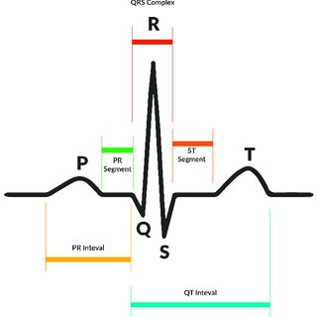

FIG 1: QRS COMPLEX

From the extracted ECG graph, we can obtain QRS complex where we can further use these data for more classification and analysis like – an QRS complex consist of Q, R, S, wave. There may be leads and may not be visible. The wave which represents the ventricular depolarization is said to be QRS complex.

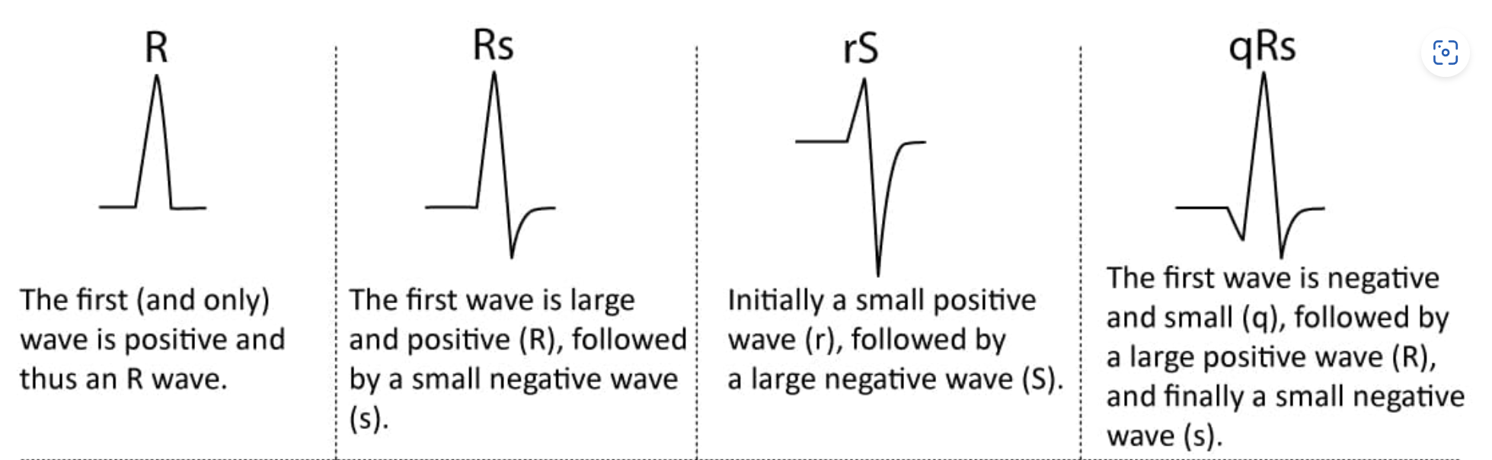

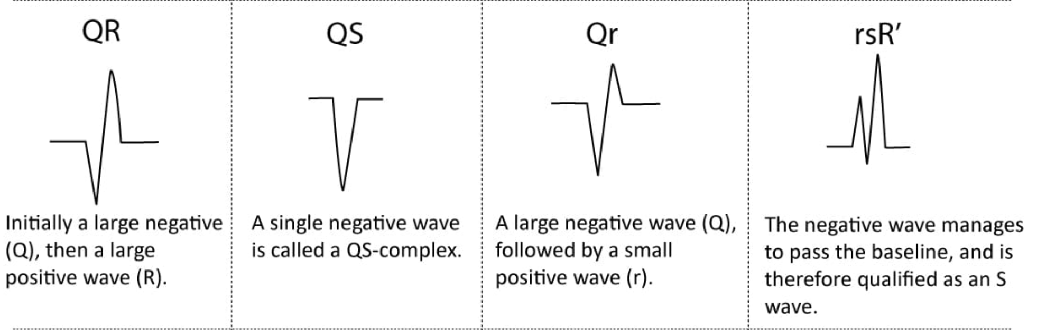

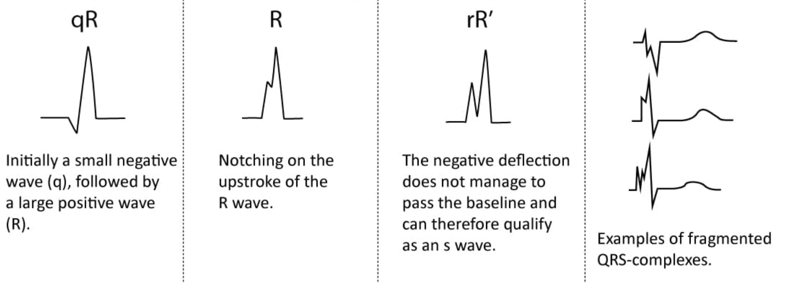

FIG 2: These are some naming of the QRS-complex.

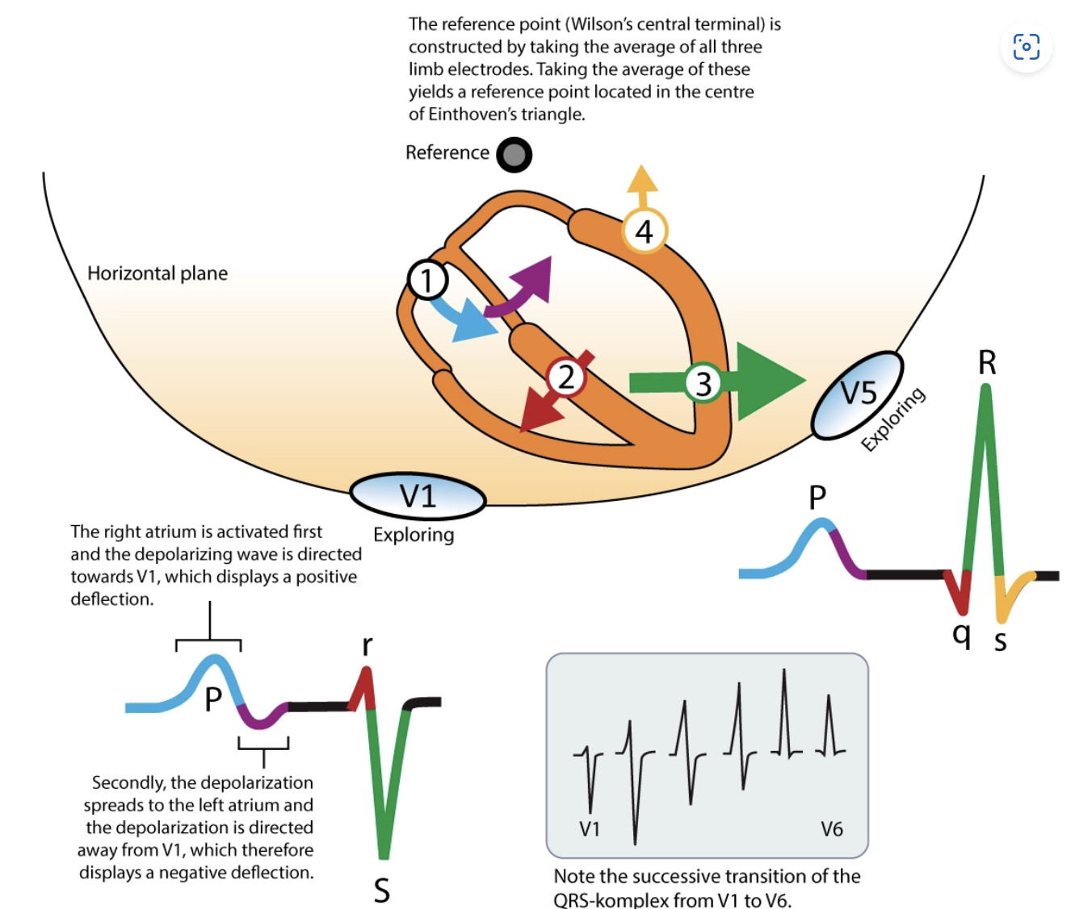

FIG 3: working function on how the ECG graph is extracted.

**PHOTOPLETHYSMOGRAM**:

PPG is an obtained optically known as plethysmogram which is often used to detect the volume of the blood volume which changes in the bed of microvascular tissue. The change in volume caused by the pressure pulse is deducted by the skin with light from the LED.



**CHAPTER 2**

**REVIEW OF THE LITERATURE**

**2.1 DESIGN AND CONSTRAUCTION:**

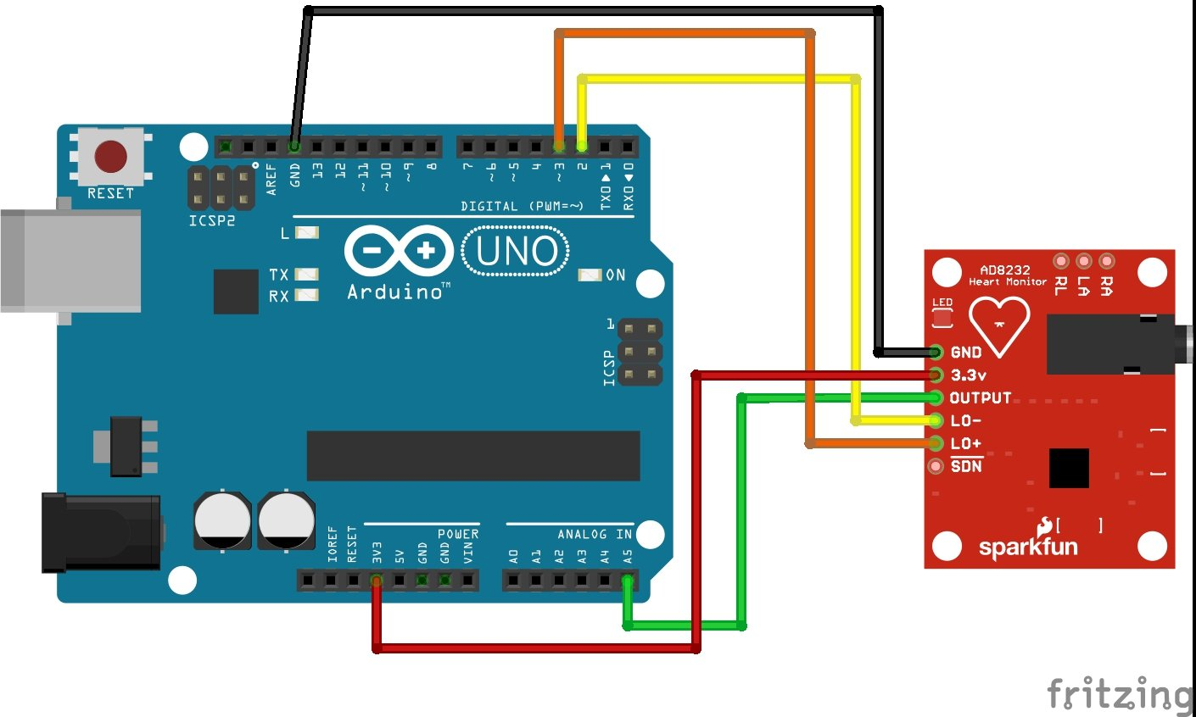

**FIG: ECG CIRCUIT.**

These is the ECG circuit design where the output is analog, these the extracted graph then processed for the QRS segments for future analysis. This is the conceptual design to extract ECG graph.

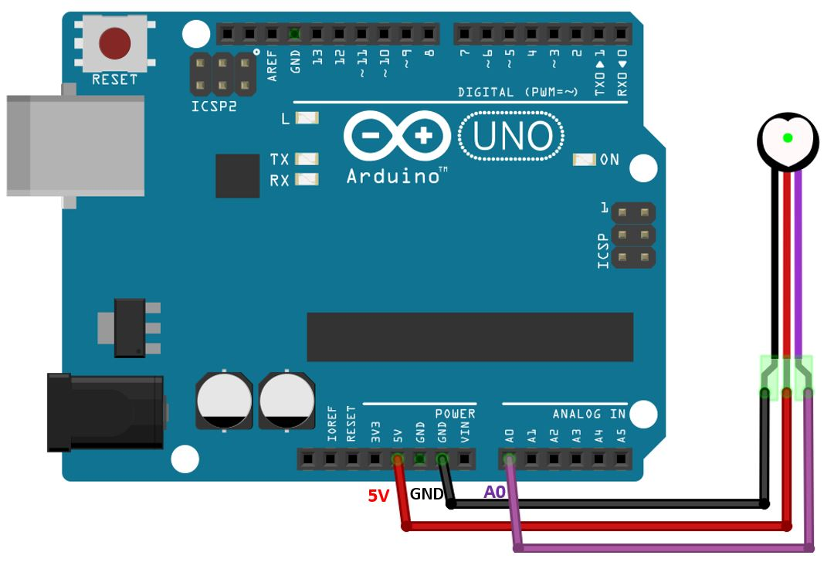

**FIG: PPG CIRCUIT.**

These is the PPG extraction design where the output is analog ,these from the data we can obtain graph and BPM and we can use it for the further processing. These is the conceptual design in father discussion in these report we use in the design strategies, specification, task distribution.

**BLOCK DIAGRAM:**

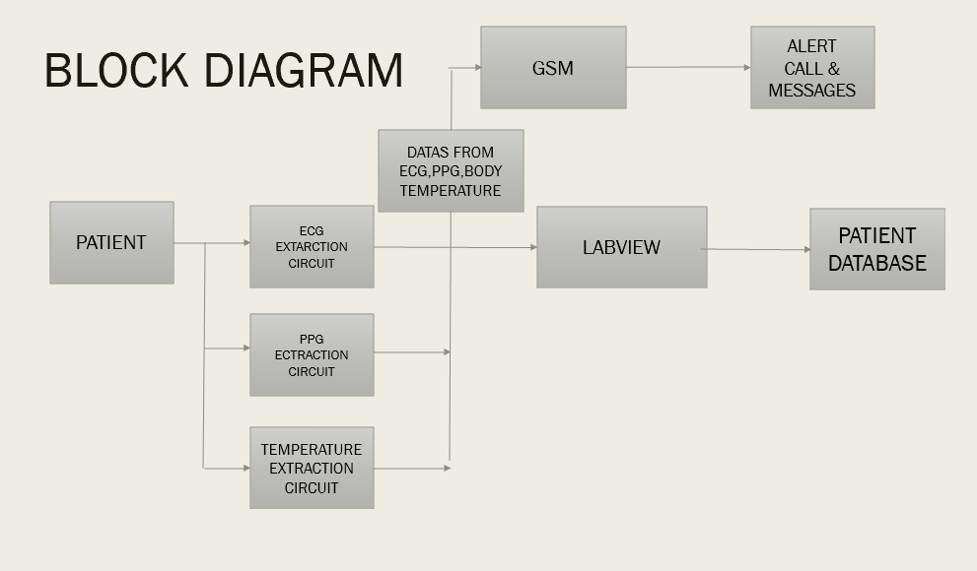

**FIG : BLOCK DIAGRAM**

In these project we will be collecting data from the patient like ECG, PPG, TEMPERATURE, from these data extracted the processed to two different systems first one we could able to see the extracted data in LabVIEW, Arduino ide, firebase (database).

In the other system the data is analyzed and process accordingly to the patients age, condition, etc. from the analysis the data is given to GSM module where it helps to receive and transfer data, also used it as “ an alert Message and call system” to the gradient and doctor .

**MODULE FOR ALERTING THE PATIENT CONDITION:**

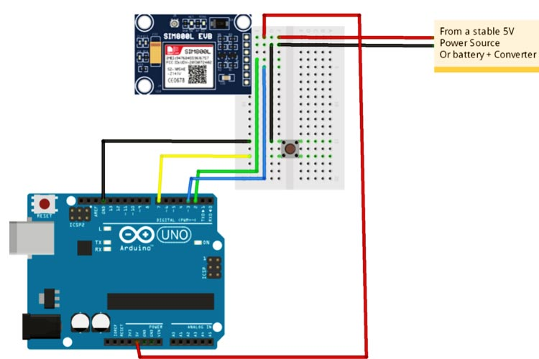

FIG: GSM MODULE

A GSM module with a serial interface is the SIM800L. It has the ability to make and take phone calls as well as send and receive text messages. It has the ability to receive FM signals and connect to the internet. The serial UART interface, as depicted, can also be used to connect a microcontroller to the SIM800L.

**CHAPTER 3**

**SCOPE OF THE PRESENT WORK**

This project aims to present assessments of cardiac disease in Electrocardiogram (ECG) Signals for Cardiac Arrhythmia by examination of the ensuing normal & abnormal waveforms. This study describes a technique for analyzing electrocardiogram (ECG) signals, extracting characteristics, and classifying heartbeats based on various arrhythmias. Tachycardia, Bradycardia, Supraventricular Tachycardia, Incomplete Bundle Branch Block, Bundle Branch Block, and Ventricular Tachycardia are examples of cardiac arrhythmia; hence, heart irregularities may result in rapid cardiac arrest or injury to the heart. For cardiac patients, early arrhythmia detection is crucial. A multi-resolution wavelet transform-based electrocardiogram (ECG) feature extraction method has been created and assessed.

PPG for Cardiovascular Disease Monitoring and Detection One of the main causes of death reported to occur worldwide is cardiovascular disease. In order to prevent a heart-related disease from developing into a serious condition, doctors and other health professionals encourage the early identification and treatment of suspected symptoms. According to the European Society of Cardiology, changes in the normal heart rate (or blood volume) activity are a key indicator of a potential cardiovascular dysfunction. Heart rate is therefore an independent risk factor for cardiovascular illnesses. Photoplethysmography, which focuses on blood volume consistency and monitoring, has made it simple for doctors to screen, detect, and keep an eye on the presence of cardiovascular disorders. Every heartbeat is typically measured by a PPG for the following parameters: pulse cycle duration, digital volume pulse, augmentation index, transit time of reflected wave, and reflection index.

**CHAPTER 4 EXPERIMENTAL PROCEDURES**

ECG EXTRACTION:

Filters, amplifiers, and sensing electrodes make up the ECG extraction circuit. The patient to whom the electrodes are attached provides the data. Three electrodes, one on each wrist of the right hand, left hand, and left leg, are affixed to the ECG monitoring platform that this sensor is connected to. The ECG data is gathered using an ECG extraction circuit, which also converts the signal from analogue to digital, before being processed using LabVIEW, transferred to the end user's GSM module, and then filtered to determine the patient's status.

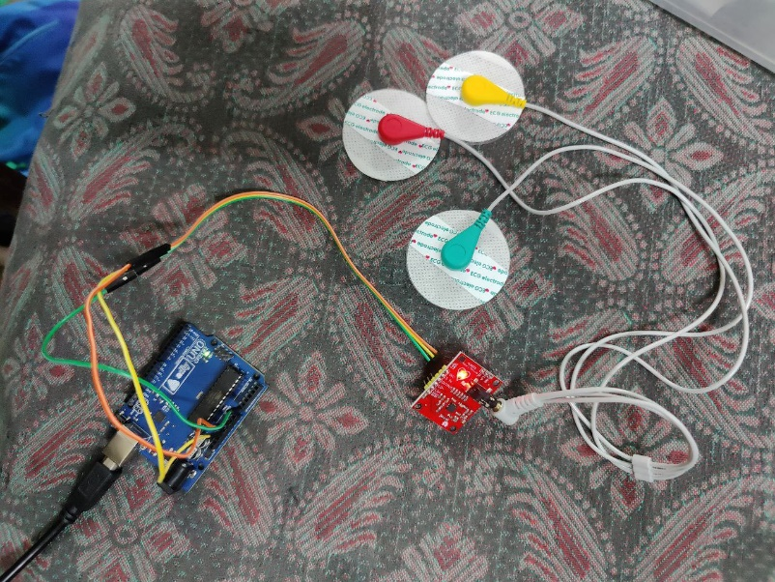

FIG: ECG EXTRACTION CIRCUIT

The data is then analyzed using LabVIEW, such as signal processing and automated data that can acquire ECG signals, amplify the signals that are acquired, and design front end hardware that aids in converting the captured data into a format that can be processed by LabVIEW, to calculate beats per minute and identify cardiac arrhythmia. The signal is filtered in LabVIEW to create an accurate P-Q-R-S-T wave, which is then used to determine the heart rate (measured in beats per minute) using the value of the R-R interval.

PPG EXTRACTION:

In the world of health-related gadgets, the pulse sensor is one of the most important sensors, and it has many different types and possibilities for us. If you wish to measure beats per minute with a heartbeat sensor or pulse sensor, this is the simplest basic sensor to start with. As a result, both the offline and internet markets offer it at a low price. Comparatively speaking to other modules on the market, this sensor is relatively small. But for the small purpose, its size has no impact on how well it works or how efficiently it performs. A straightforward circuit is used to measure blood volume by detecting light reflections caused by blood moving through blood arteries. The single pin, known as the out pin, is used to deliver the sensor's output. It uses pulse signals to communicate with the microcontroller. The sensor operates on the incredibly straightforward idea of light reflection. The method is known as the photoplethysmogram. The play of algorithms used to process data from the sensor makes up the remaining portion. The photoplethysmogram principle dictates that the light used for reflection is often RED/GREEN optics. These two lights, along with the one I suggested above, are used in all other heartbeat sensors. The received light is transformed into a voltage signal pulse that is either supplied directly or indirectly through an Op-Amp to low logic level microcontrollers.

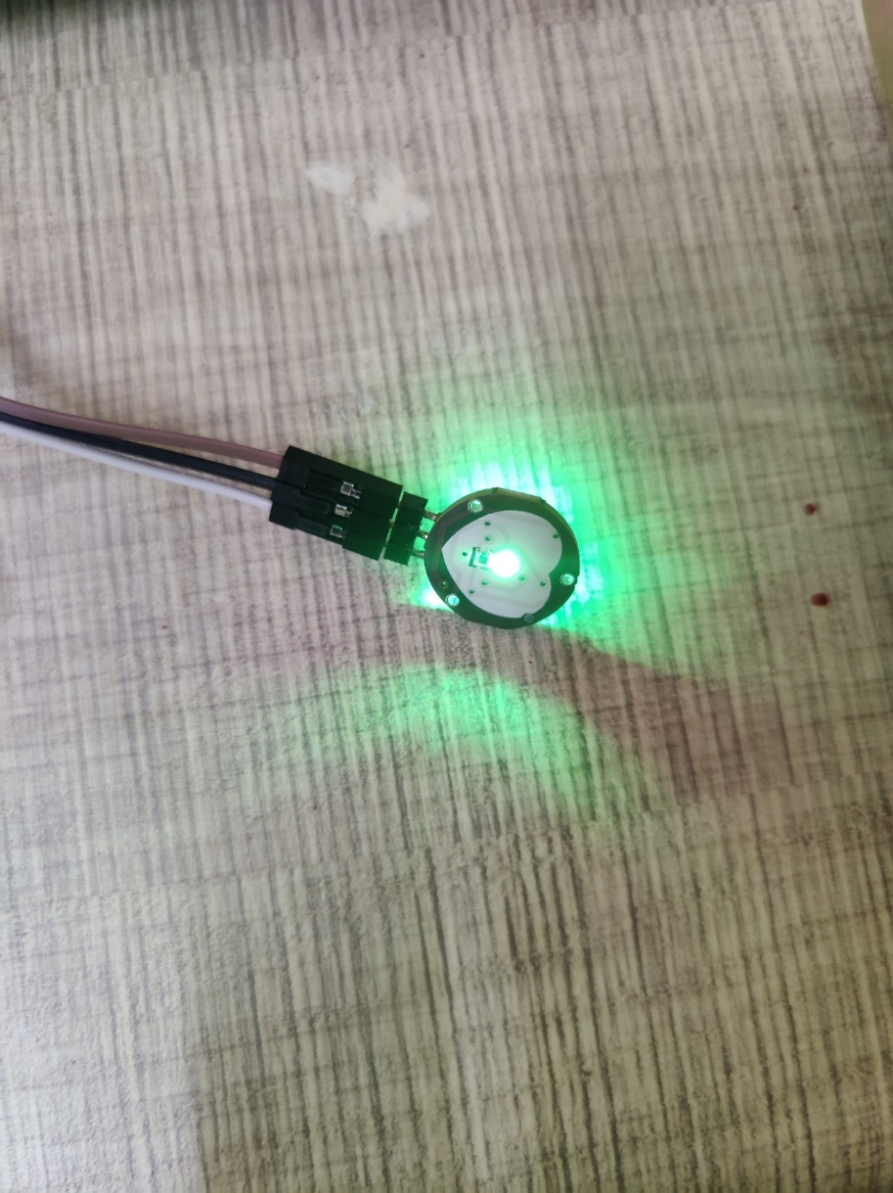

FIG: PPG EXTRACTION CIRCUIT

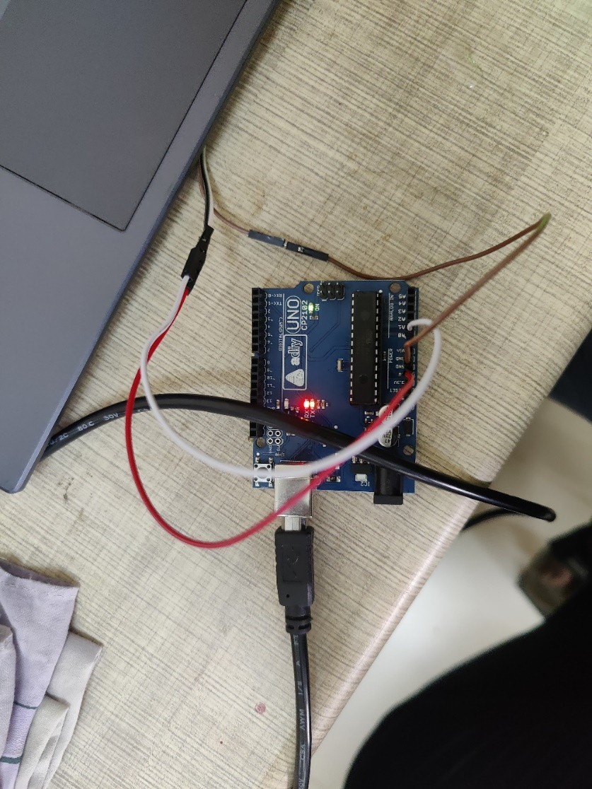

FIG : PPG EXTRACTION CIRCUIT

TEMPRATURE:

Creating the circuit for extraction for temperature. Before beginning the project, disconnect the Arduino's USB cable. The flat side of the LM35 must face you when it is positioned anywhere horizontally on your breadboard. After that, join the three wires to the sensor's three pins. The wire on the left will connect to the Arduino's 5v (+5 volts) supply. The analogue output will be on the center wire. The right-hand wire will connect to the Arduino's GND pin. Open the serial monitor while the code is uploaded and temperature readings are displayed. Verify the serial monitor is set to 9600 bauds.

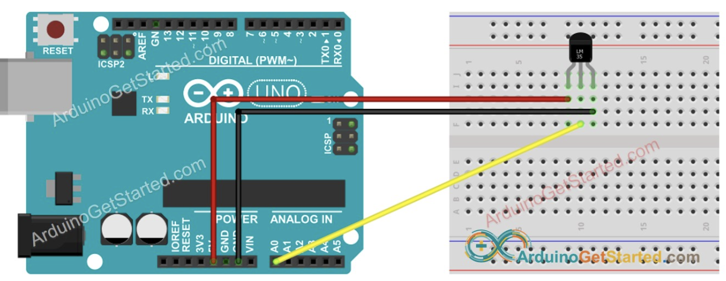

FIG: BODY TEMPERATURE CIRCUIT

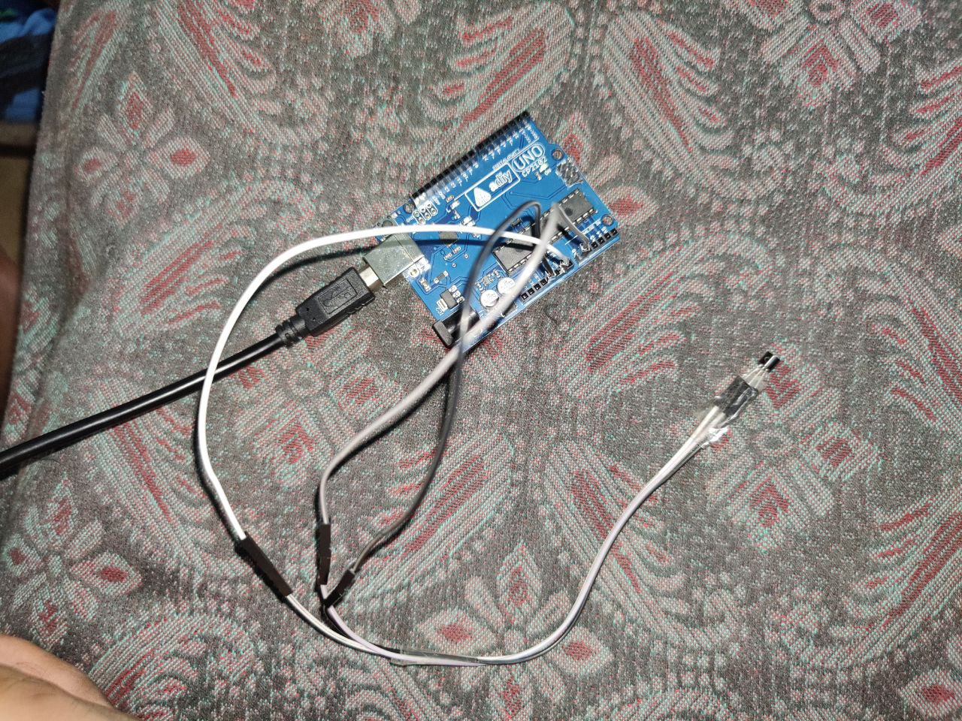

FIG: ACTUAL CIRCUIT

GSM MODULE:

The SIM800L GSM/GPRS module is a tiny GSM modem that can be used in numerous Internet of Things (IoT) projects. Almost all tasks that a typical cell phone can perform, including as making phone calls, sending SMS messages, connecting to the Internet via GPRS, and much more, may be carried out with this module. And to top it all off, the module works almost everywhere in the world because it supports quad-band GSM/GPRS networks. The silcon chip, which powers GSM mobile phones, is its brains. This module can work between 3.4 and 4.4 volts. Since the arduino board only has 3.3 and 5 volts, we must use a LiPo battery or dc-to-dc converter to supply power. It is therefore a smart choice for embedding in projects with limited space.

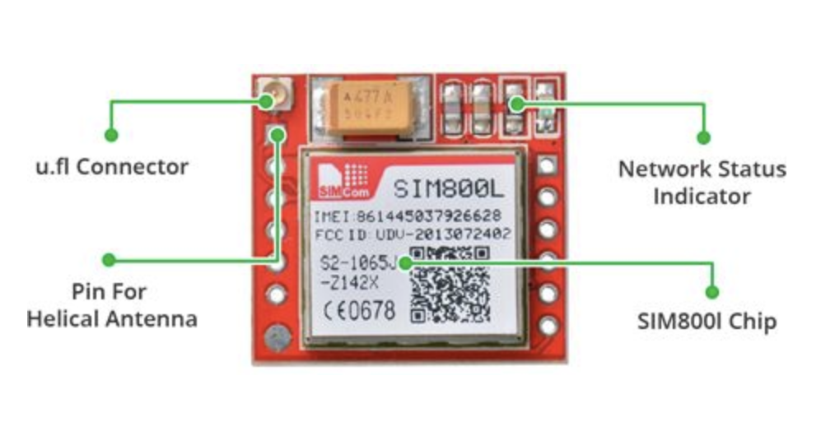

FIG: GSM DISCRIPTION

The SIM800L GSM chip's required data pins, including the pins needed for USART communication with the microcontroller, are all broken out to 0.1′′pitch headers. From 1200bps to 115200bps in baud rate, the module is Compatible.

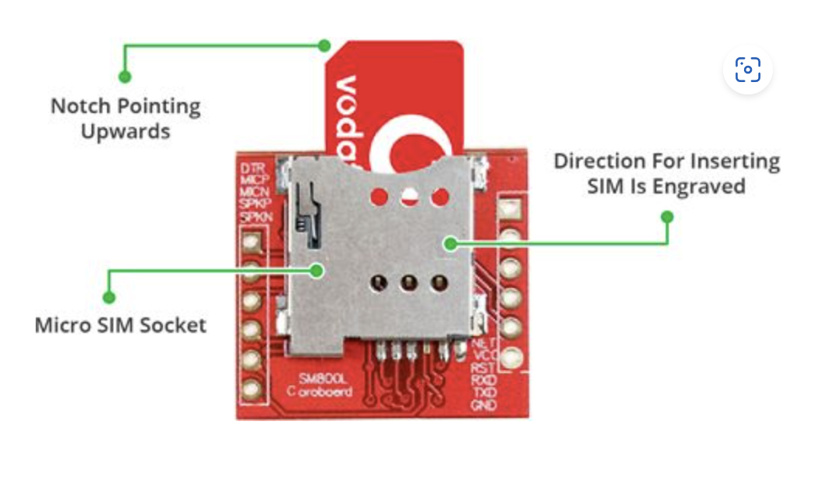

FIG : GSM SIM SOCKET

On the back, there will be a SIM socket. Any 2G Micro SIM card will operate without a hitch. On the surface of the SIM socket, the proper SIM card insertion direction is typically engraved.

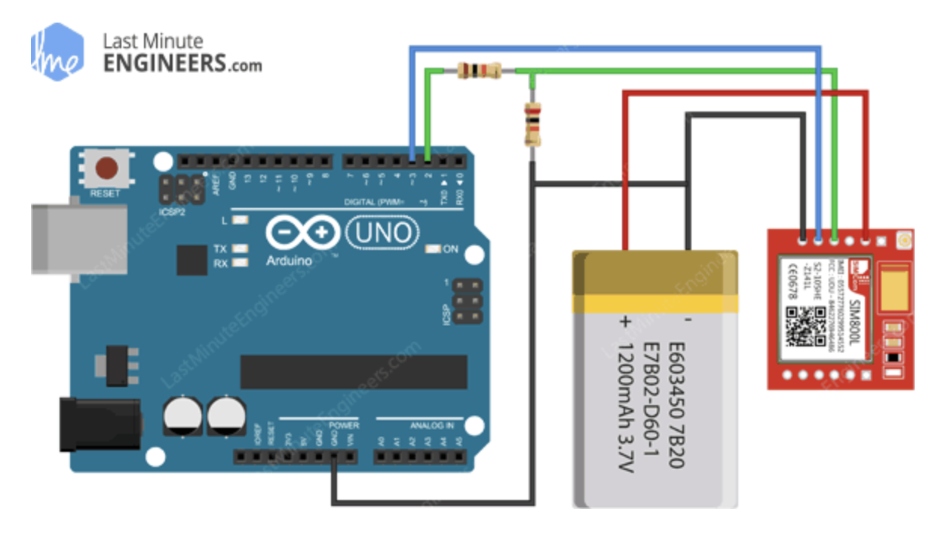

FIG: GSM CIRCUIT

GSM’S FEATURES:

This tiny chip contains a surprisingly large number of features. Here are a few of the features:

* Supports GSM 850, EGSM 900, DCS 1800, and PCS 1900 quad-band.
* Connect with any global GSM network with 2G SIM not working JIO sim.
* Use an external 8-ohm speaker and electret microphone to place and receive voice calls.
* Send and receive SMS.
* Send and receive GPRS (TCP/IP, HTTP, etc.)
* Scan and receive FM broadcasts.
* AT Command Set as serial-based.
* FL connectors for antennae.
* Micro SIM Card port available.

LED - STATUS INDICATOR:  
 An LED that shows the status of the network connection is located on the upper right of the SIM800L module. Depending on the condition it's in, it blinks at various rates:

SELE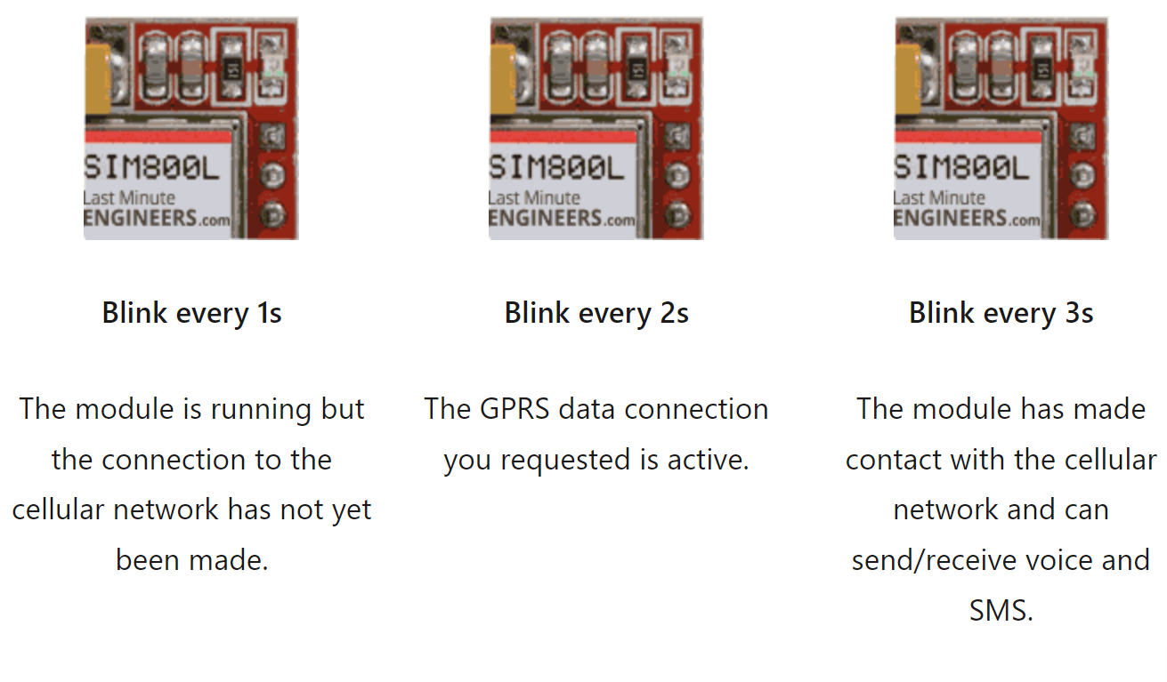

FIG: GSM LED INDICATOR

SELECTING ANTENA:

Any sort of speech or data connection using the module requires the usage of an antenna. Therefore, choosing an antenna will be crucial. The SIM800L module can accommodate an antenna in one of two ways. The first is a helical antenna that can be soldered directly onto the board and is typically included with the module. For projects that need to conserve space, this antenna is quite helpful. But be mindful that it can have trouble connecting, particularly with 3dBi GSM antenna because we'll not be using it in patient rooms. Another option is - U. FL to SMA adaptor which is available online. This antenna fits into the tiny U. FL connector on the module's upper left corner by snapping it in place. We are utilizing this kind of antenna since it performs better and even enables you to put your module inside a metal box as long as the antenna is outside.

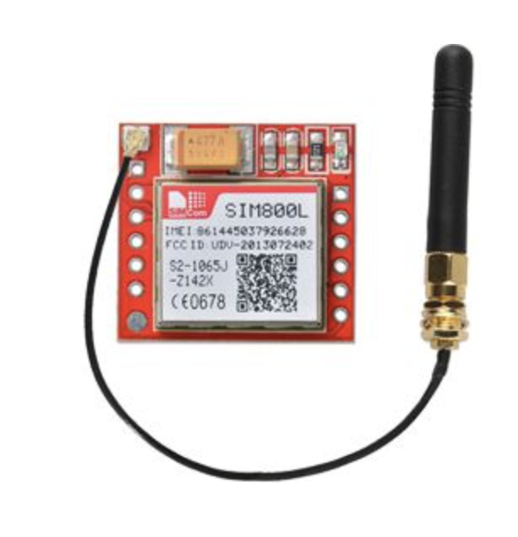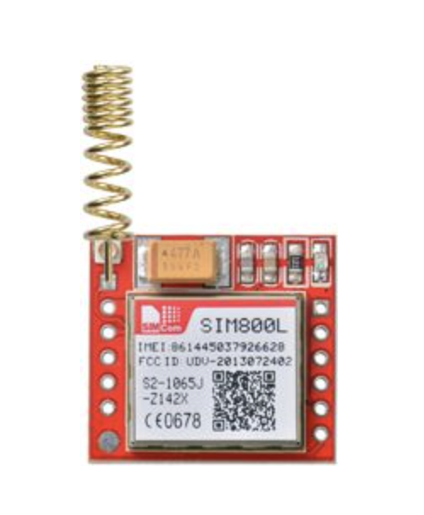

FIG: ANTENA 1 FIG: ANTENA 2

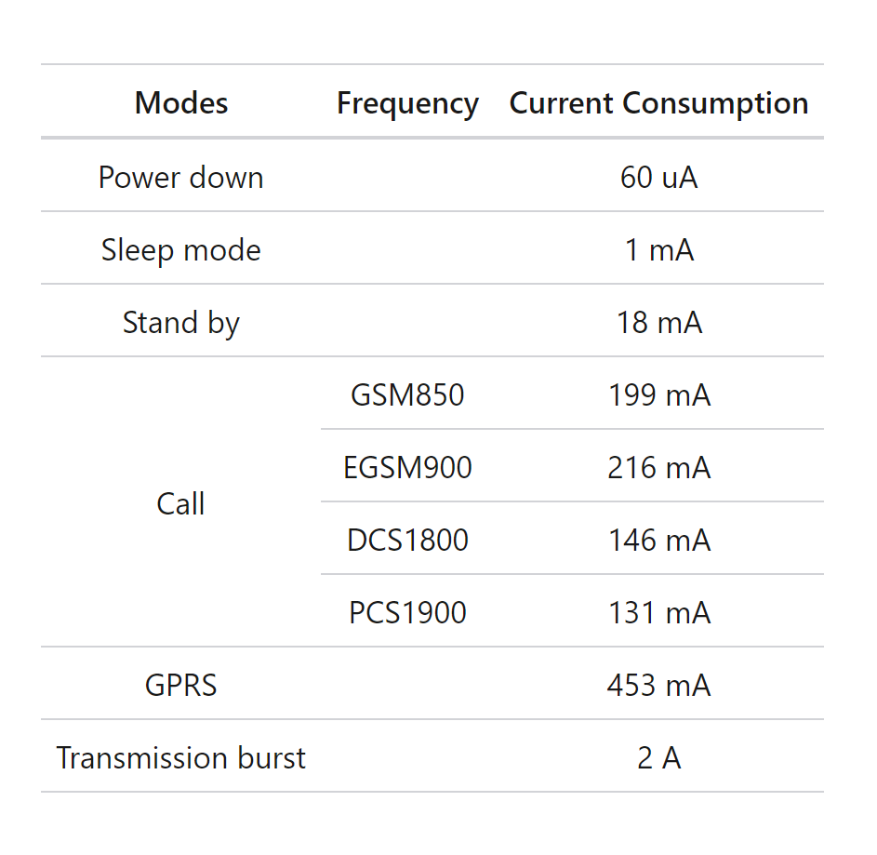

FIG: GSM SPECIFICATION

**POWER SUPPLY:**

LI-Po 3.7volt BATTERY:

One benefit of Li-Po batteries is that they often have voltages between 3.7V and 4.2V, which is ideal for a SIM800L module. Any Li-Po battery with a capacity of 1200mAh or more may work well because it can maintain the proper voltage range even under spikes of up to 2 Amp.

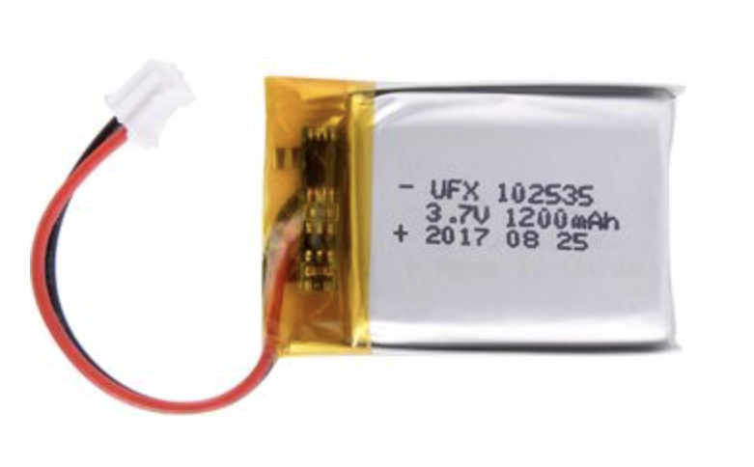

FIG : 3.7 VOLT BATTERY

DC to DC BUCK CONVERTER:

Any DC-DC buck converter with a 2A rating, such as the LM2596, will do. Compared to linear voltage regulators like the LM317 or LM338 these are far more efficient.

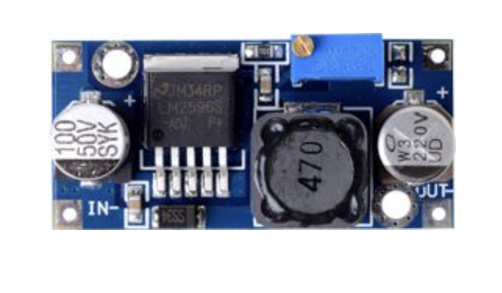

FIG: DC-DC CONVERTER

GSM ALERT CIRCUIT:

In my project I used RPS(regulated power source) as power source .

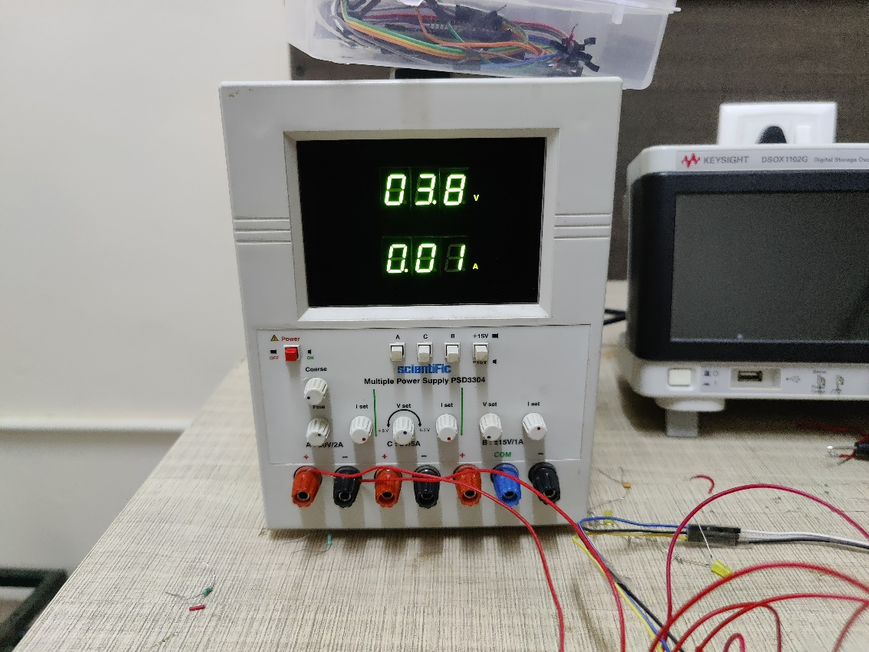

FIG: GSM POWER SUPPLY

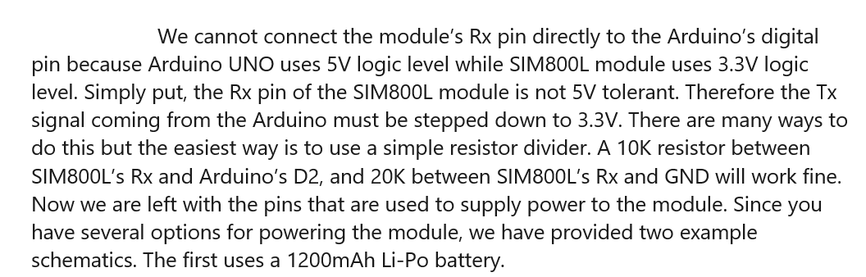

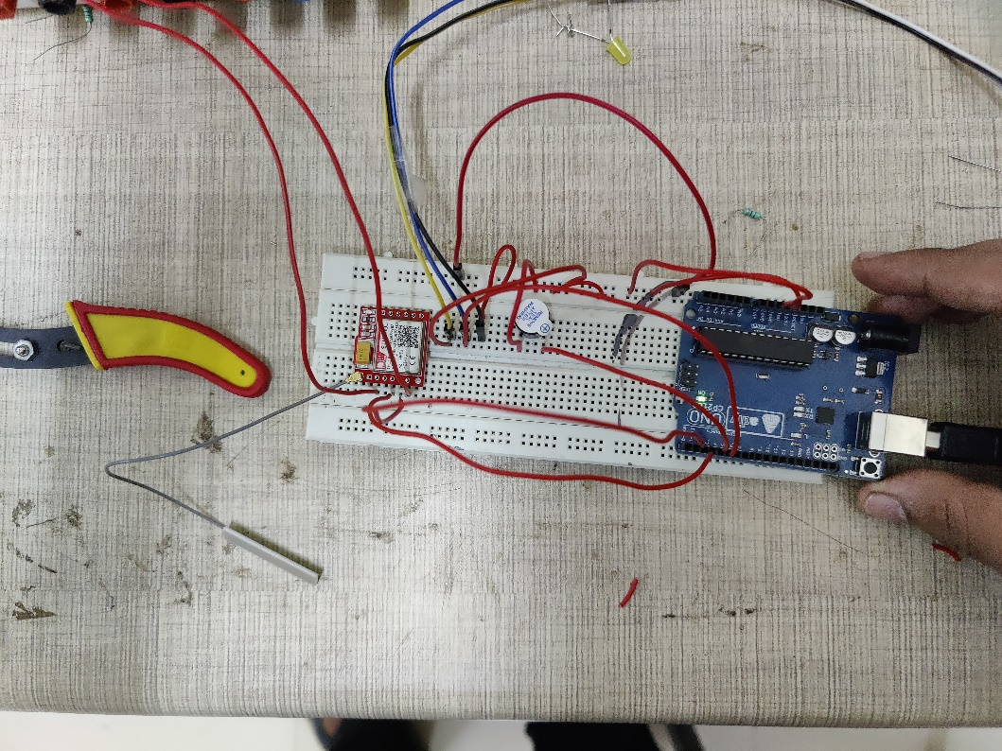

FIG: GSM ALERT SYSTEM

DATABASE:

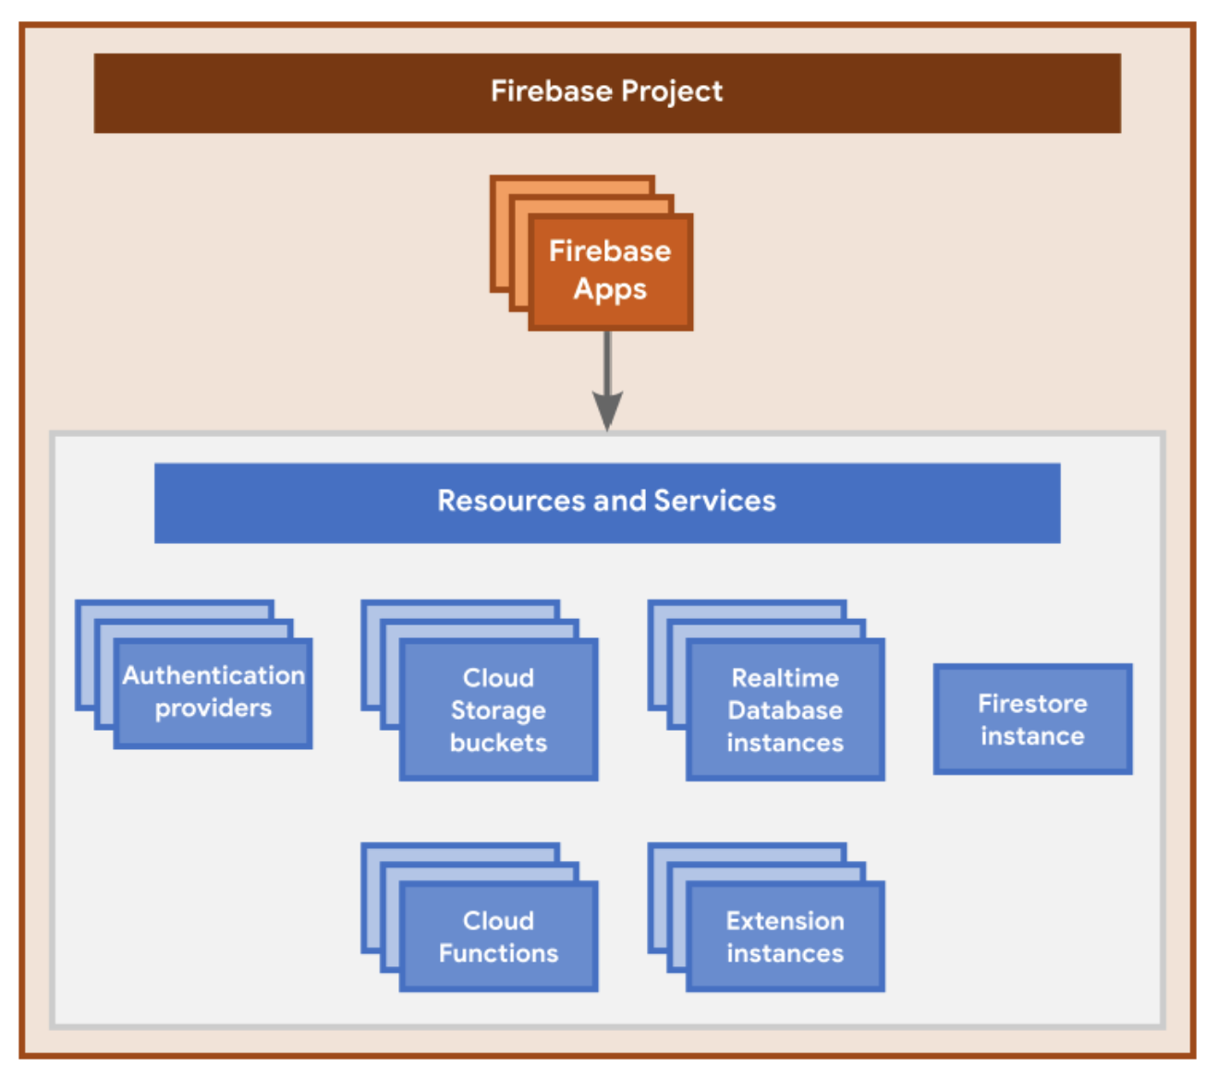

ARDUINO IDE:

So, we are using GSM, PPG, LM35, ECG, ARDIUNO BOARD

To interface with microcontroller we need IDE to code it to make the microcontroller to understand.

We need to download library from the IDE to interface with sensor.

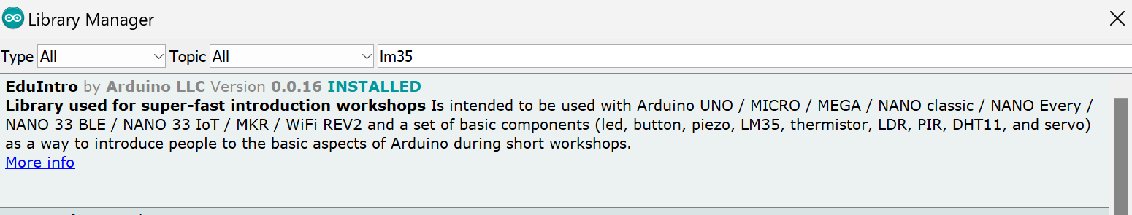

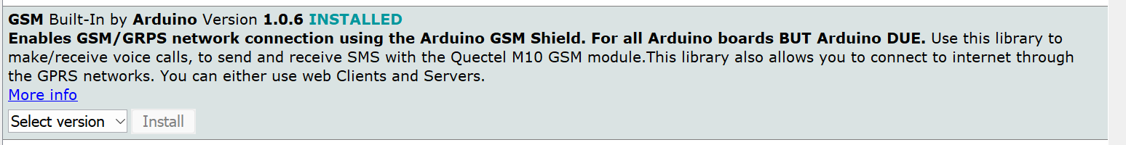



To interface with the data acquired we need to install LINX library in LabVIEW.

ARDIUNO CODE:

For GSM:

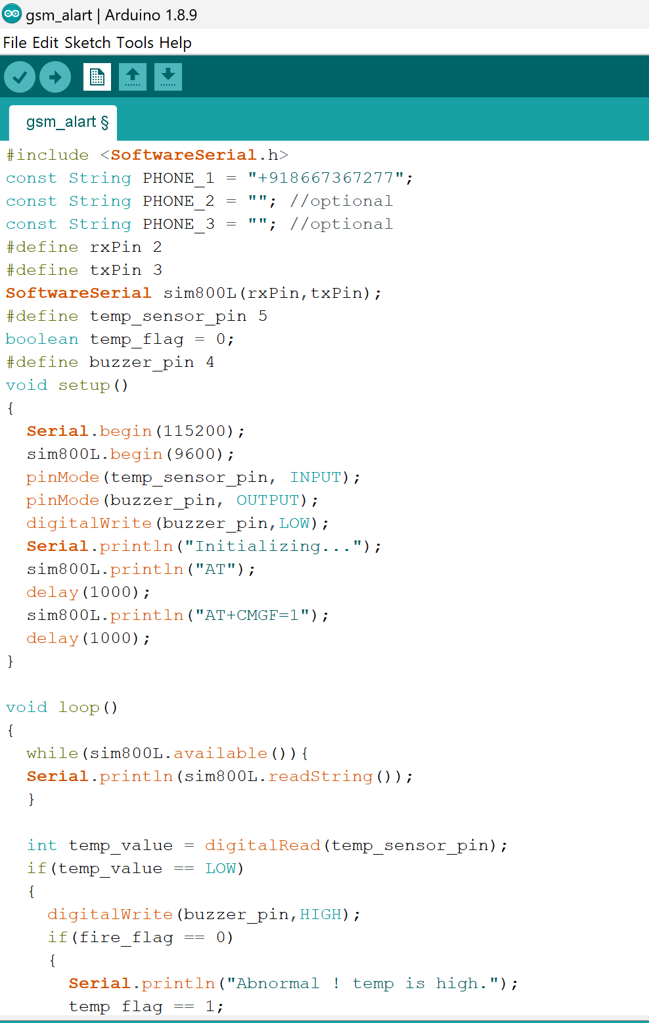

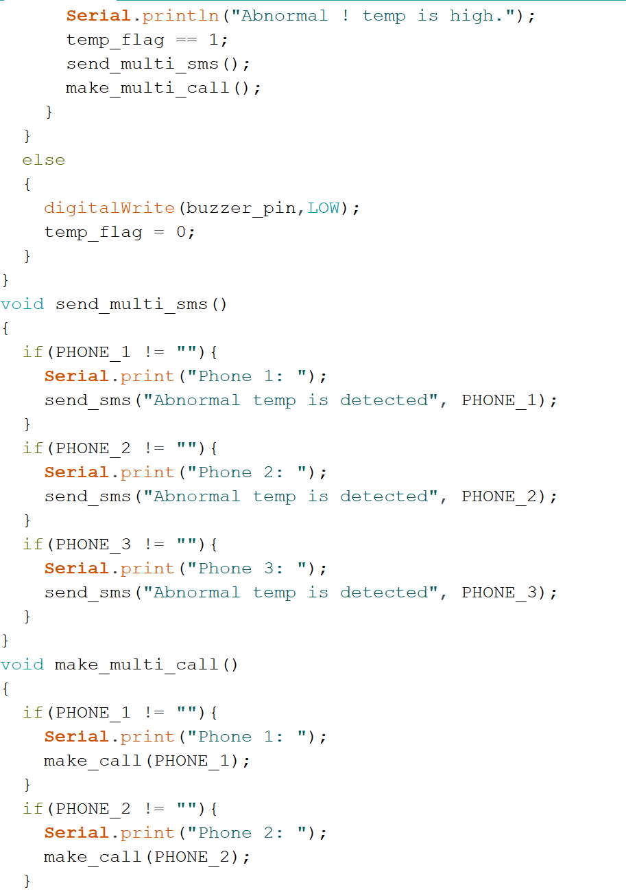

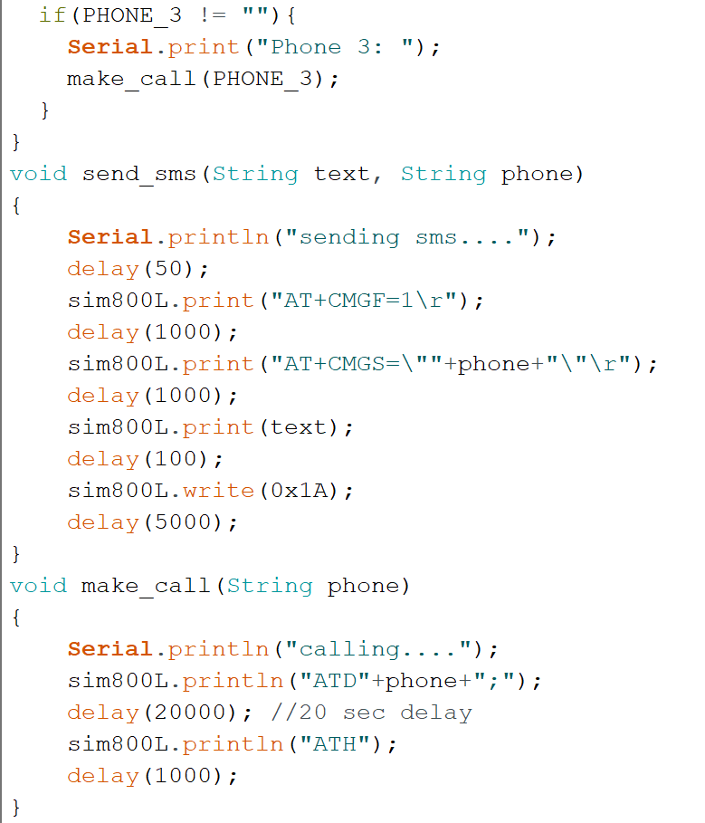

FOR PPG CODE: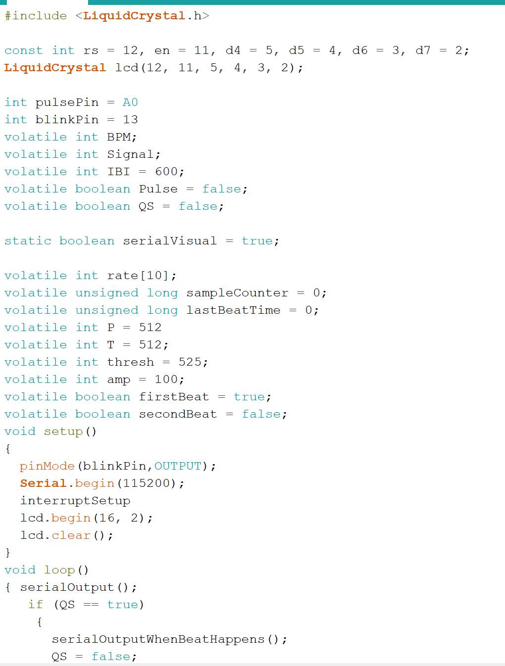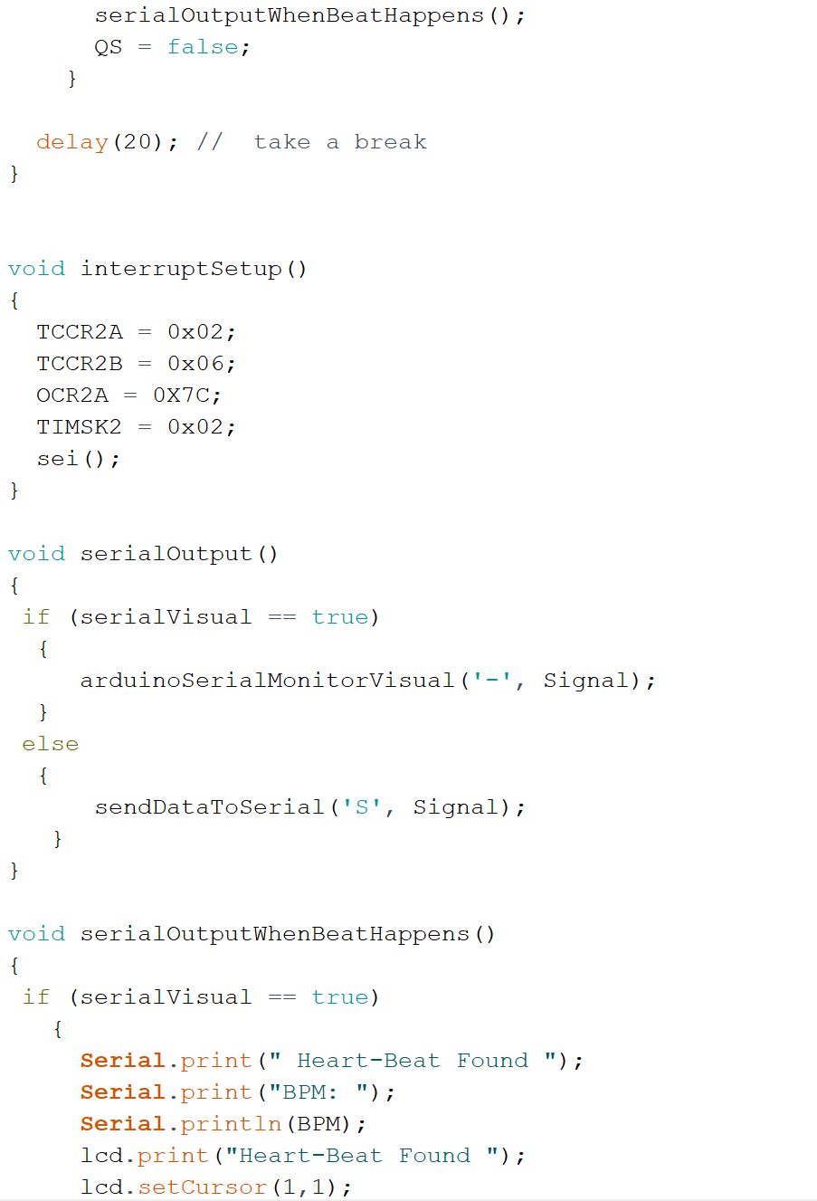

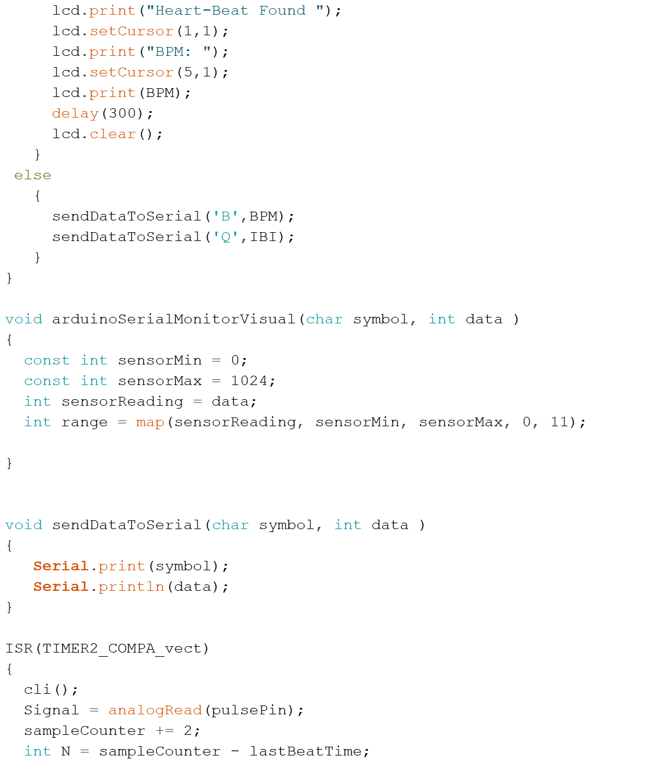

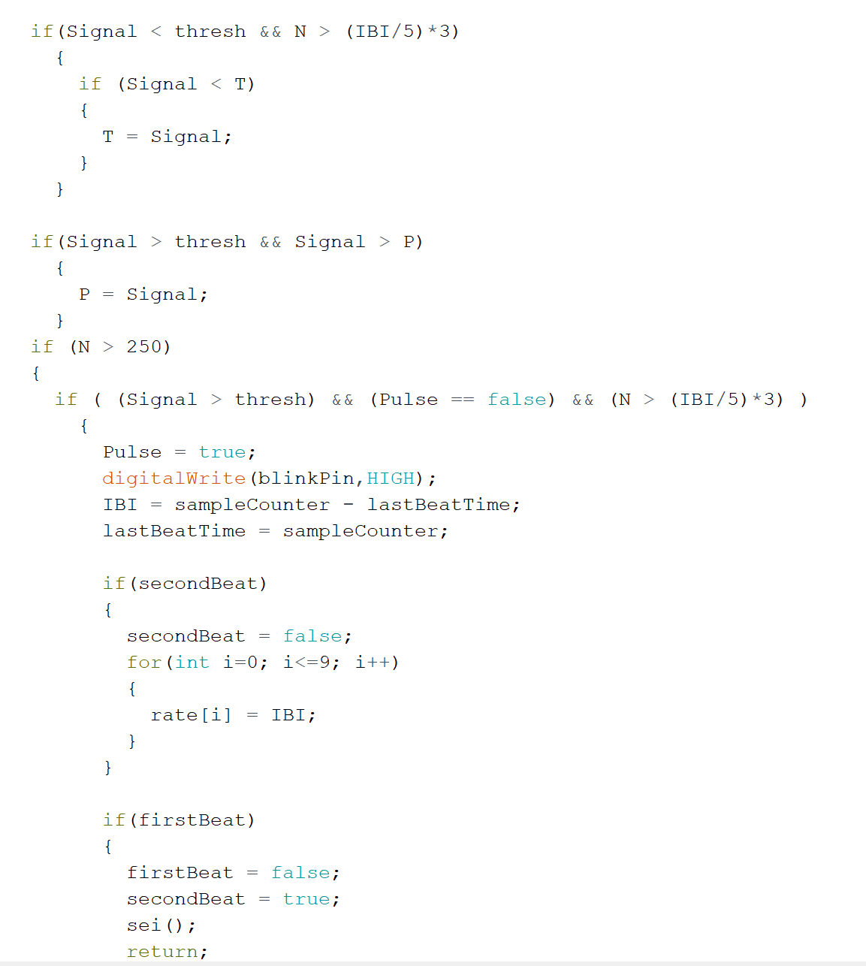

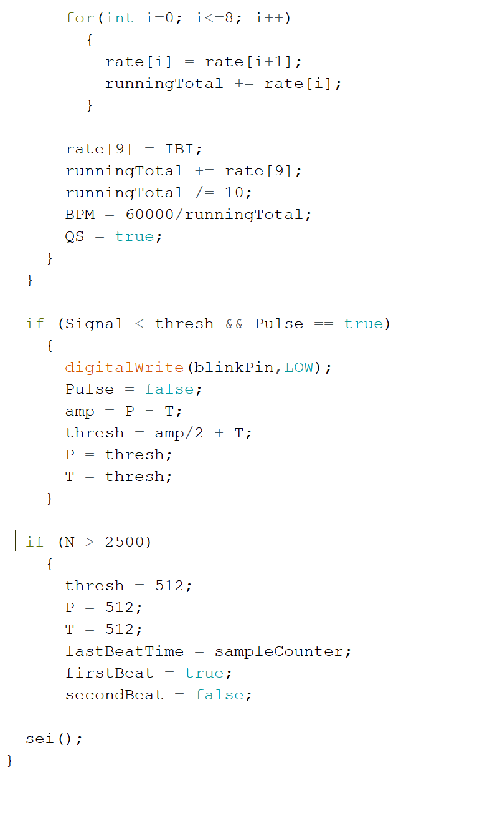

**CHAPTER 5 RESULTS AND DISCUSSION:**

After all the connection given as per the above studies, and there is the practical implement of the concepts here are some results, For ECG, The ECG is made up of a number of electrodes that are wired to the machine and affixed to the patient's body. The actual device is a graphing device (originally paper, although electronic recorders are becoming more common). Each sensor is capable of detecting a change in the skin's electrical charge, which can only be the result of impulses moving from the heart to the rest of the body. As it spreads throughout the body, this impulse moves very quickly and is also transmitted to the cells that surround the heart. For patients who do have heart issues, like arrhythmia, this establishes control by forming a very regular pattern. The term "ECG lead" refers to the signal that is captured as the difference between two potentials on the body's surface. It is said that each lead approaches the heart from a different perspective. 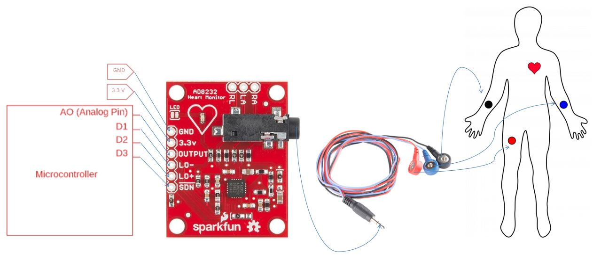

FIG: ECG LEAD PLACEMENT

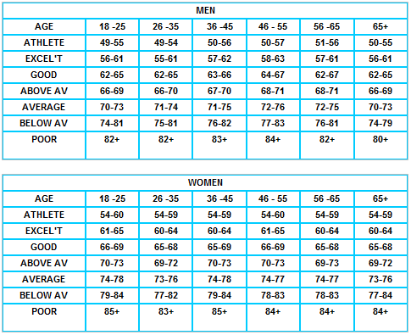

FIG: BPM CHART

From the data acquired from the sensors the BPM can be analyzed, accordingly, the BPM varies among ages and gender.

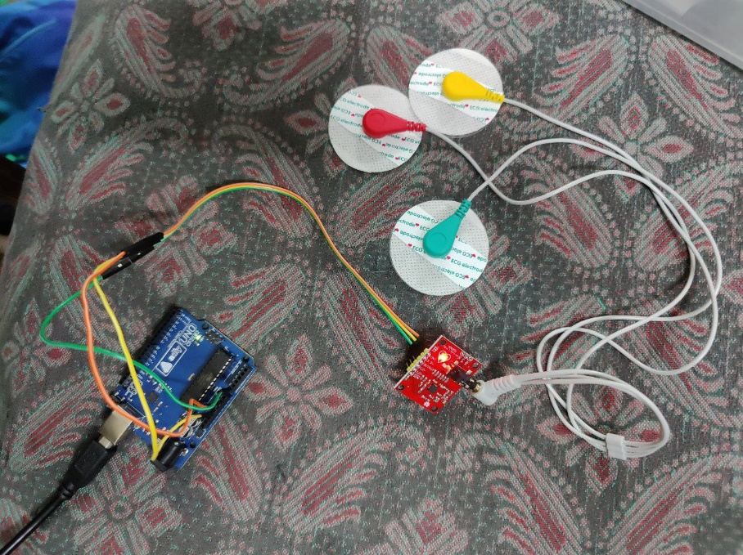

FIG:ECG CONNECTING LEADS

**LABVIEW RESULT**:

FRONT PANEL:

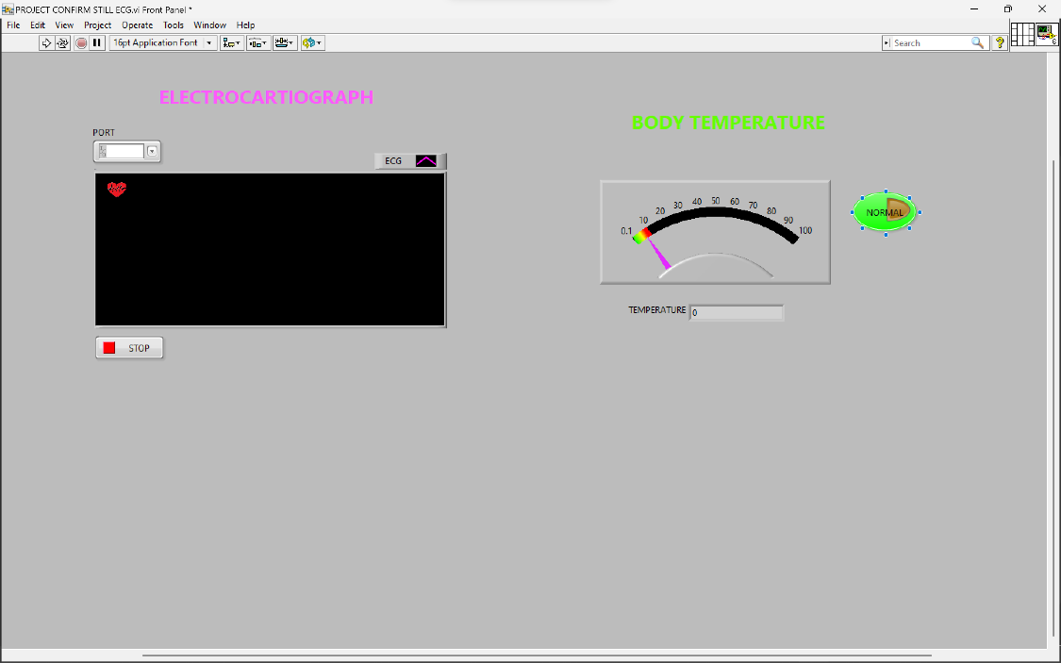

FIG: FRONT PANEL

BLOCK DIAGRAM:

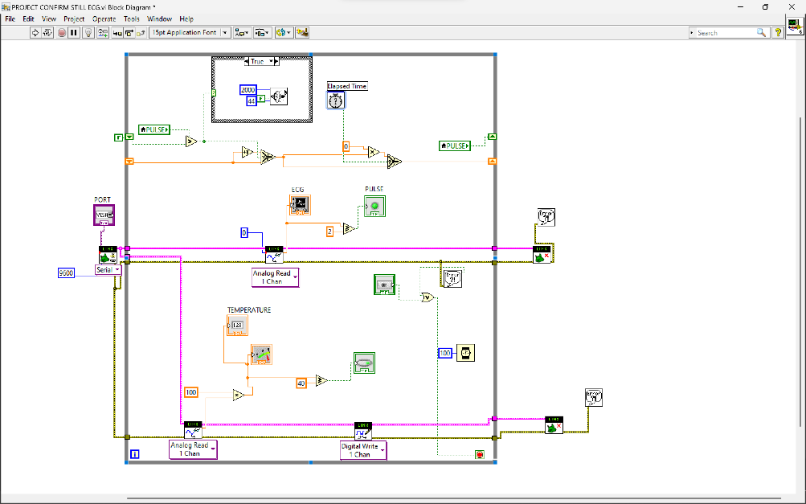

FIG: BLOCK DIAGRAM

**DATA EXTRACTION AND PROCESSING**

-GRAPH WHEN TEMPERATURE CROSS 40’C

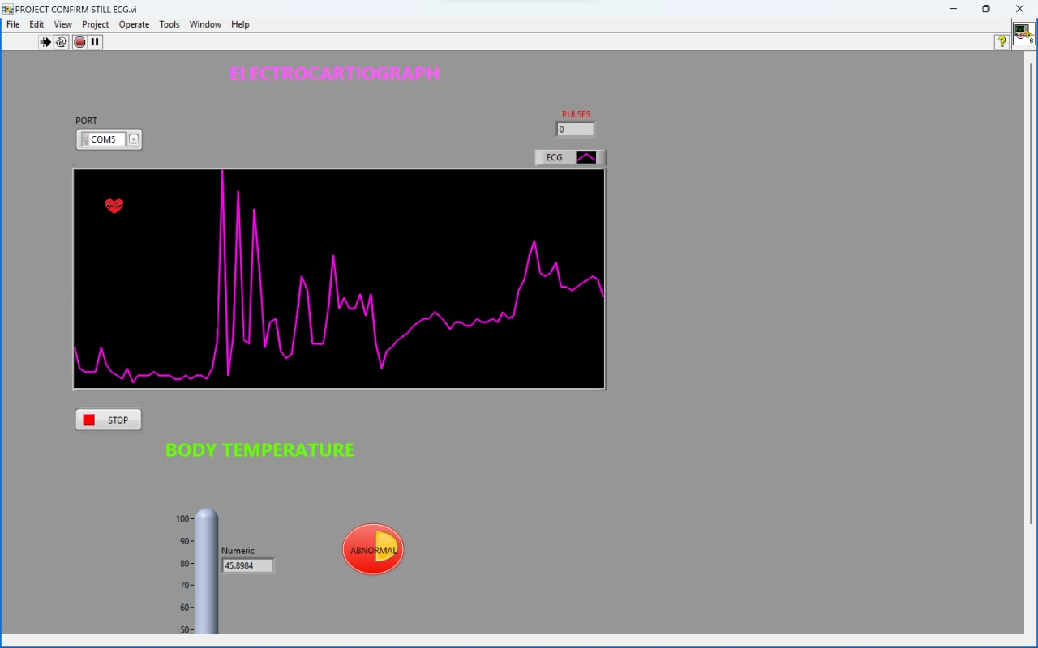

-GRAPH WHEN TEMPERATURE BELOW 40’C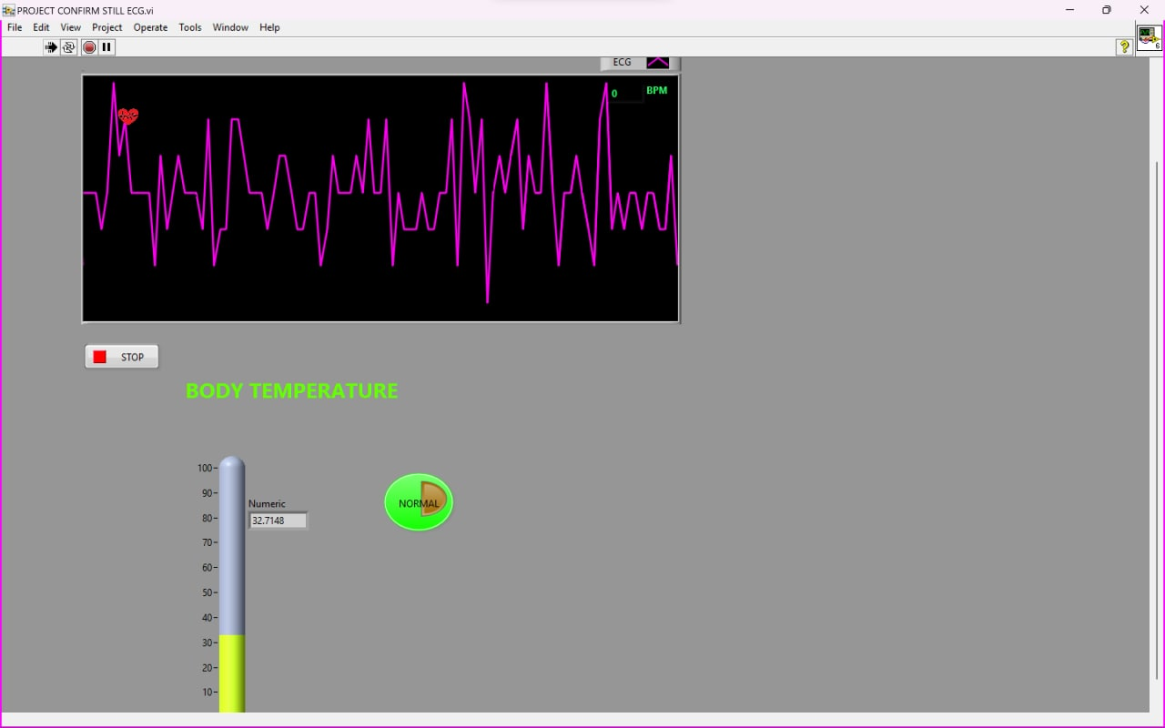

-GRAPH OF PPG SIGNAL

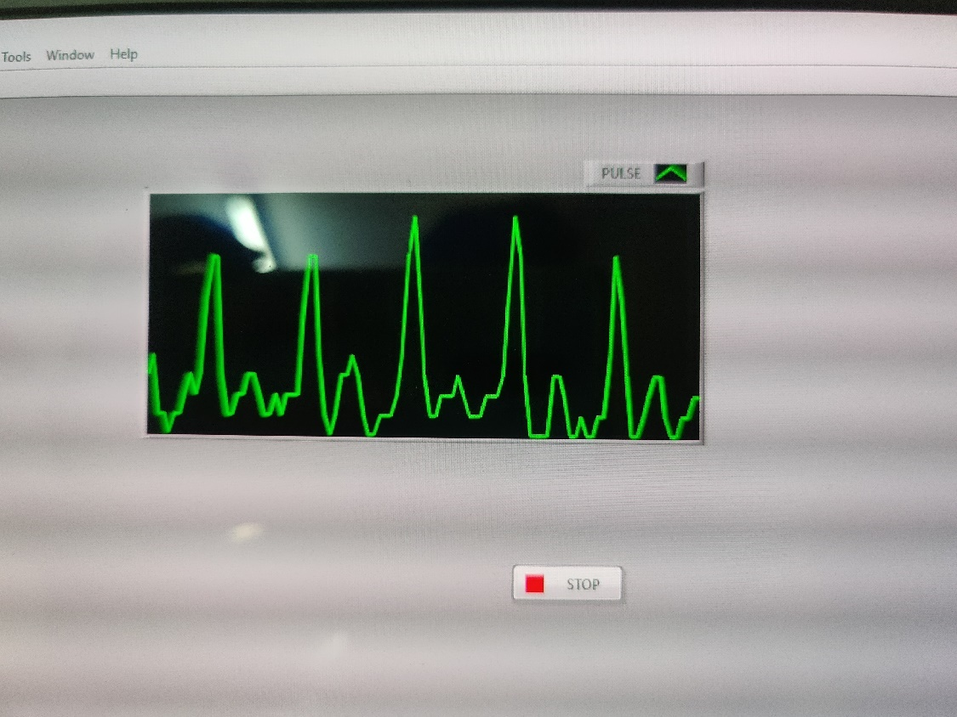

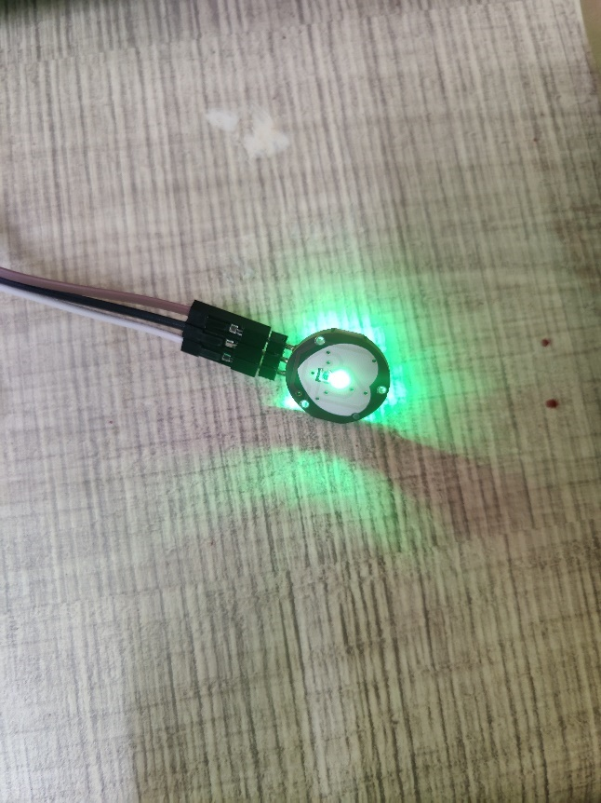

FIG: PPG OUTOUT

FIG: PPG SENSOR

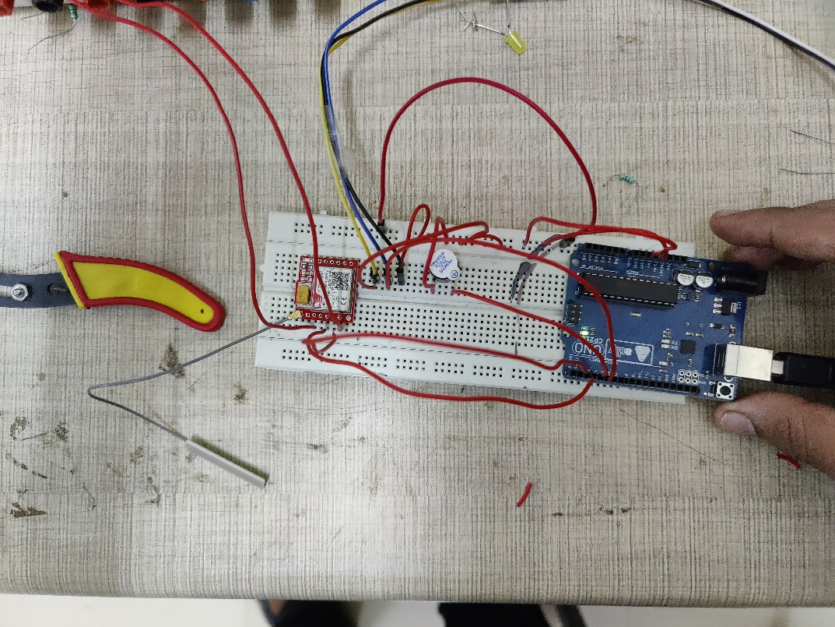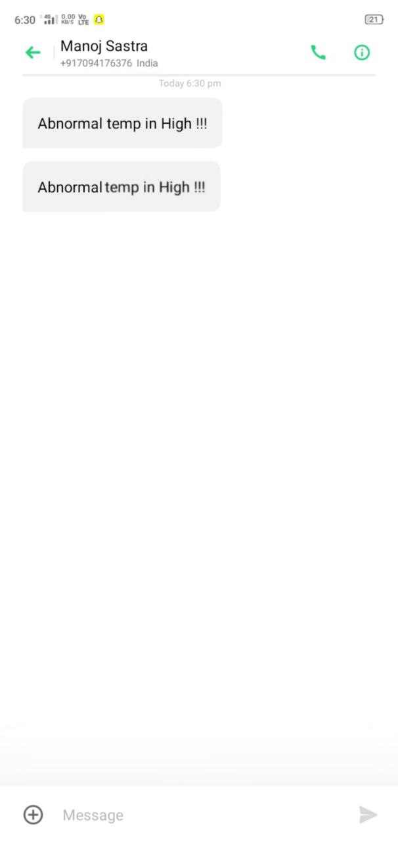**GSM MODULE RESULT**

-ALERT MESSAGE AND CALL USING GSM

FIG: GSM PRACTICAL OUTPUT

FIG: ALRET MESSAGE

SERIAL MONITER OUTPUT

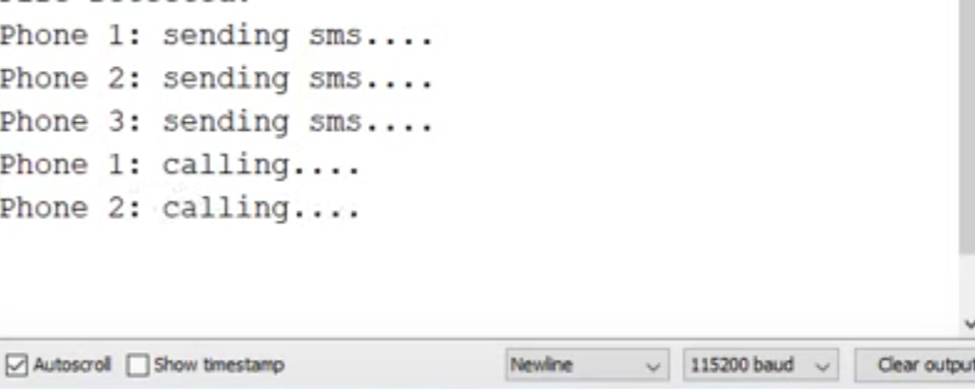

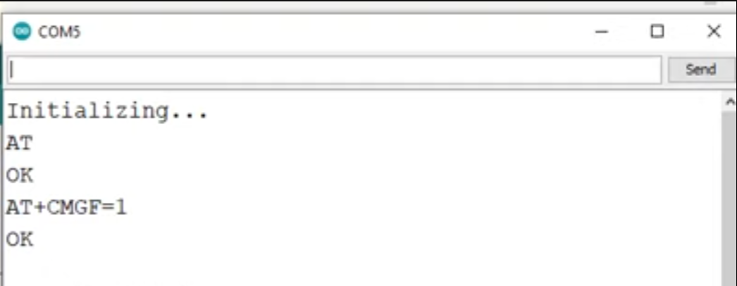

FIG: SERIAL OUTPUT

**CHAPTER 6 CONCLUSION:**

The software built in LabVIEW and Arduino IDE for continuously monitoring ECG, PPG, body temperature, and beats per minute (BPM) data has been detailed in this study, along with hardware implementations utilising commercially available devices. The ECG signals, PPG, temperature, and the rate and regularity of heartbeats are all intended to be collected and analysed by this system.It focuses on database maintenance using LabVIEW, the acquisition and analysis of hemodynamic measurements, and the detection of cardiac arrhythmia. Cardiologists and healthcare systems will benefit from this system's assistance in diagnosing various arrhythmia kinds. The proposed system runs on a local level. The ability to execute code remotely and offline using LabVIEW and the Arduino IDE, or to publish results online using Firebase, is a potential future development. In the context of the first cardiac activity analysis and alarm system performed in a general medical setting, we must carefully evaluate how valuable such characteristics are. The apparatus has been improved to include a second plethysmography sensor linked to a temperature sensor. The heart-hand and heart-foot pulse waves' frequency and amplitude will be used to examine peripheral arterial circulation characteristics. His method involves evaluating the patient to determine if the presence of a disease is likely or not. Testing the technology on patients with concomitant cardiovascular diseases under hospital conditions will also contribute to future validation. This will provide additional proof that the system has been implemented correctly.

REFERENCES:

[l] A Mhatre, S Pai, N Rajput Volume III, Issue IX, September 2014(Page no. 128-131):Temporal Analysis of ECG using LabVIEW

[2] John A Kastor, —Cardiac Arrhythmias], University of Maryland,Baltimore, Maryland, USA.

[3] Elizabeth M. Cherry and Flavio H. Fenton, —Heart Structure,Function and Arrhythmiasl, Department of Biomedical Sciences,College of Veterinary Medicine,Cornell University.http://thevirtualheart.org

[4] H. Sahool and K. Biswal, "Patient monitoring system for cardiovascular patient with body temperature using lab VIEW," International Journal of Engineering Research and Development, vol. 6, no. 8, pp. 27—30, 2013.

[5] C. Saritha, V. Sukanya, and Y. Narasimha Murthy, "ECG signal analysis using wavelet transforms," Bulgarian Journal of Physics, vol. 35, Article ID 13100157, pp. 68-77, 2008.

[6] Dawit Mekonnen and M. B. Malarvili , Research Article OpenAccessVolume 2015 IArticleID 701520 | https://doi.org/l().1155/2015/701520:Labview Based ECG Patient Monitoring System for Cardiovascular Patient Using SMTP Technology.

[7] Nina Djermanova,Marin Marinov,Borislav Ganev,Serafim Tabakov,Georgi Nikolov 2016 XXV International Scientific Conference Electronics (ET) DOI: 10.1109/ET.2016.7753471: LabVIEW based ECG signal acquisition and analysis

[8] Ayse Nur Ay, Mustafa Zahid Yildlz , Baris Boru Sakarya Universitesi Fen Bilimleri Enstitüsü Dergisi, vol. 21, no. 4: pp. 576-583, 2017 Doi IO. 16984/saufenbilder.287418: Real-time featureextraction of ECG signals using Nl LabVIEW

[9] T.P. Utomo, N. Nuryani, and A.S. Nugroho, "Automatic QRS-complex peak detector based on moving average and thresholding," J. of Physics Conf. Series, vol. 1153, pp. 1-6, Aug. 2018.

[10] K.W. Nam, J.M. Ahn, Y.L Hwang, G.R. Jeon, D.P. Jang, and I.Y. Kim, "A Phonocardiogram Based noise robust real-time heart rate monitoring algorithm for outpatients during normal activities," J. of Mech- in Medicine and Biology, vol. 1 8, issue 5, pp. I - 18, Jul. 2018.

[l I] G.Y. Son, and S. Kwon, "Classification of Heart Sound Signal Using Multiple Features," MDPI J. Applied Sciences Basel, vol. 8, issue 12, pp. 1 - 14, Nov. 2018.

[12] O. Yildirim, and T. Kayikcioglu, "Detecting Cardiac Arrhythmia by Using Time Differences of Double Wavelength PPG Peaks," Proc. Of IEEE 26th Signal Proc. and Comm- App. Conference (SIU), pp. I — 4, May 2018.

[13] V. Ordodi, L. Måtiu-lovan, G. Bärbulescu, D. Bonciog, D. Nistor, D. Crisnic, and G. Tänasie, "Experimental Elecrophysyological device for the appreciacion of the cardiac systolic function — a pilot study," UMFT J. Physiology (Fiziologia), vol. 29, issue 2, pp. 4— 7, 2019-

[14] H.E. Ulmer, E.W. Heupel, and G. Weckesser, "Mechanocardiographic assesment of systolic time intervals in normal children," J, Basic Res. Cardiology, vol. 77, issue 2, pp. 197-212, 1982.

[15] D. Dobreanu, Fiziologia inimii, Univ. Press, Tg. Mures, 2007.

[16] N. Giordano, and M. Knaflitz, "A Novel Method for Measuring the Timing of Heart Sound Components through Digital Phonocardiography," J, Sensors (Basel), vol. 19, issue 8, pp. I — 16, Apr. 2019.